**Problem Statement:**

You work for XYZ Corporation. Your corporation wants to launch a new

web-based application and they do not want their servers to be running all the

time. It should also be managed by AWS. Implement suitable solutions.

**Tasks To Be Performed:**

1. Create a sample Python Lambda function.

2. Set the Lambda Trigger as SQS and send a message to test invocations.

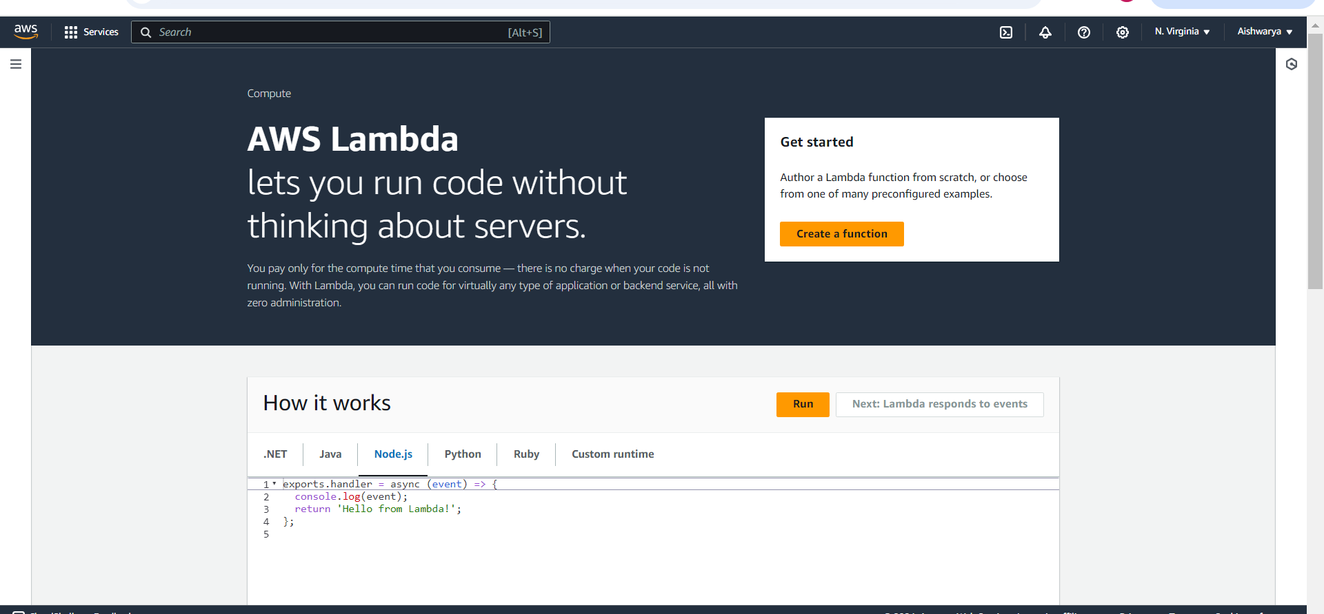

Create lambda function

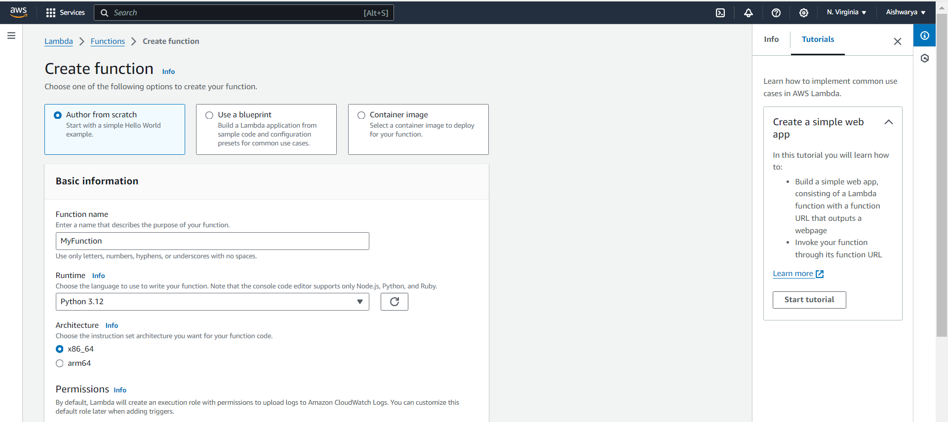

Choose default role

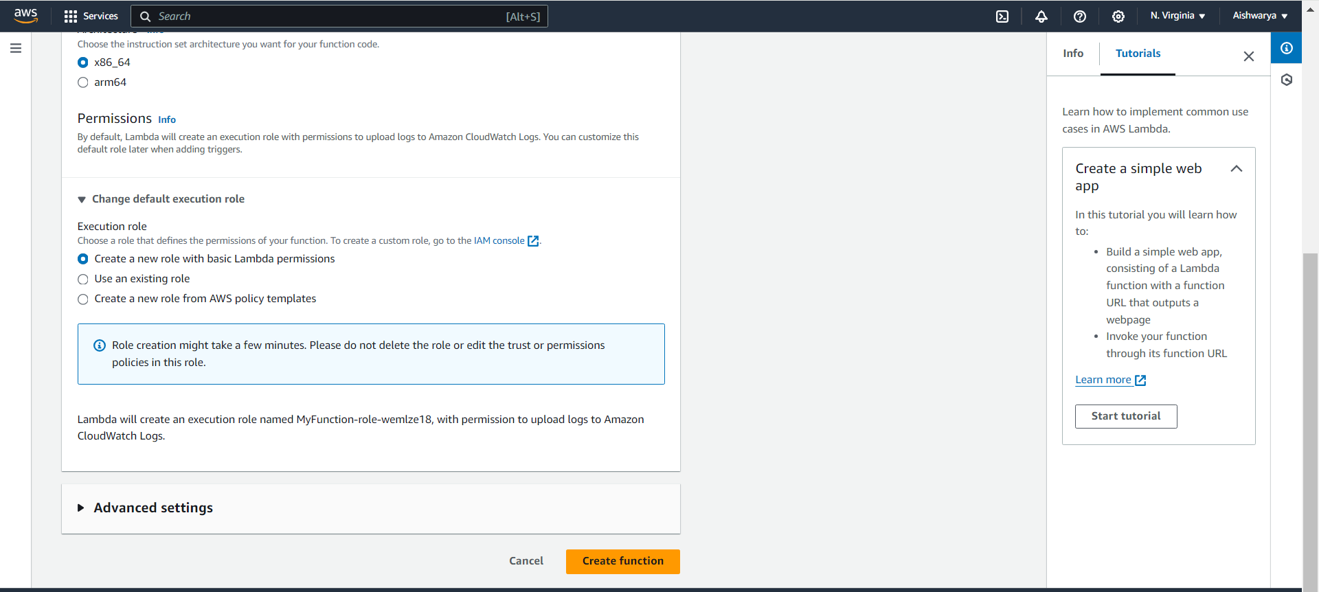

Now add code :

import json

def lambda_handler(event, context):

# Log the received event

print("Received event: " + json.dumps(event, indent=2))

# Sample processing logic

message_body = event['Records'][0]['body']

print(f"Processing message: {message_body}")

# Return a success message

return {

'statusCode': 200,

'body': json.dumps('Message processed successfully!')

}

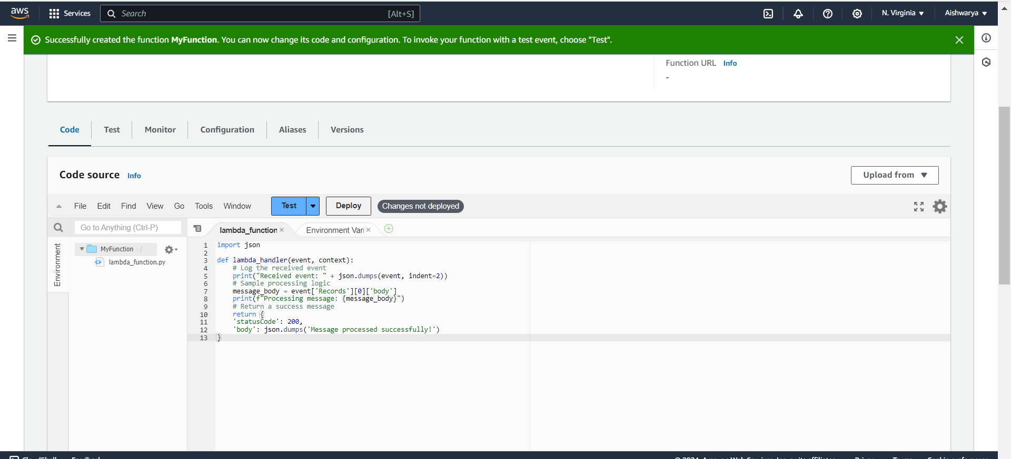

Now deploy code

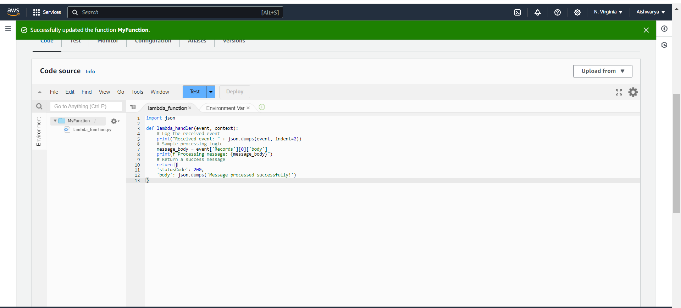

Now create SQS

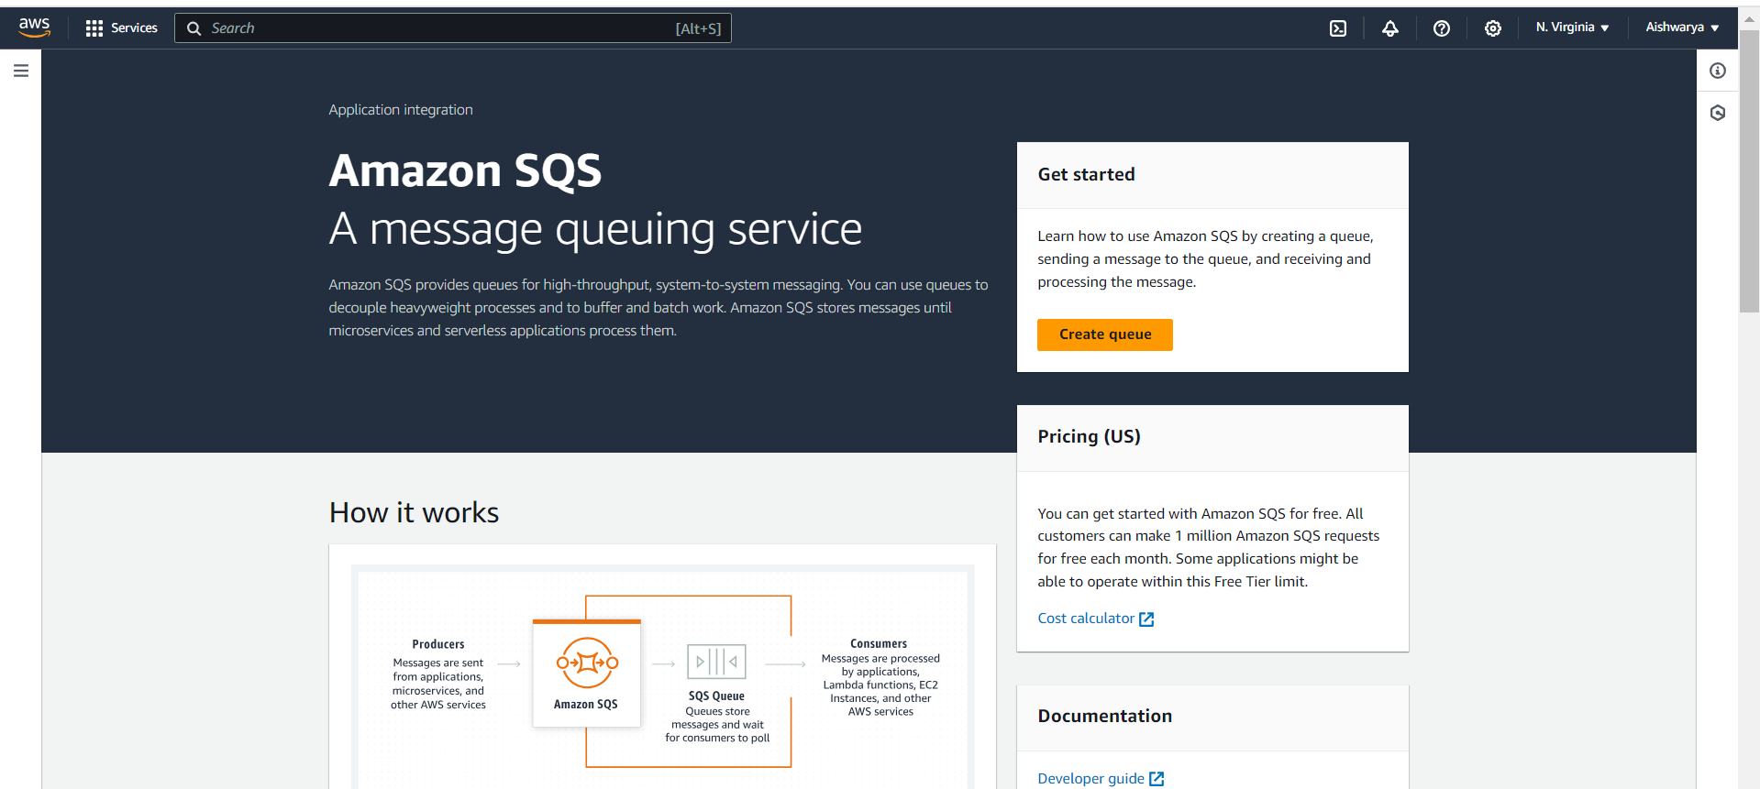

Create queue

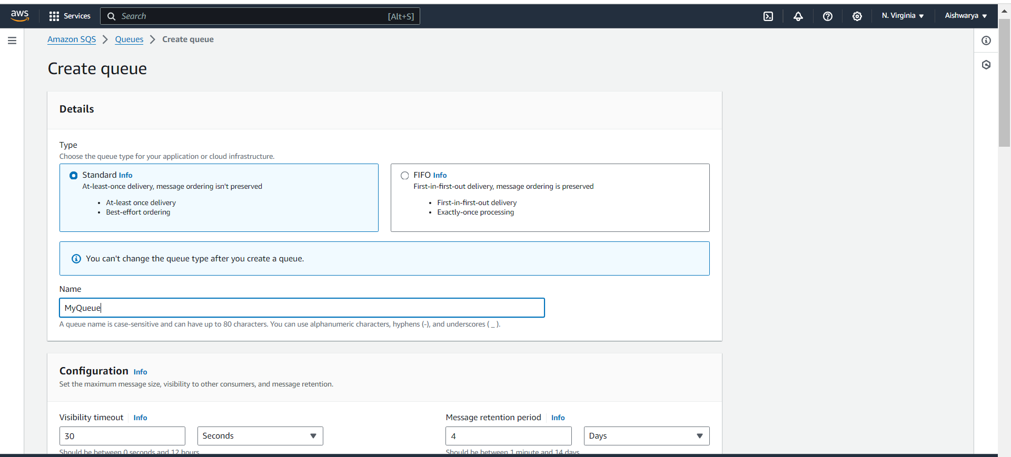

Now Add lambda trigger to SQS

Click on add Trigger.

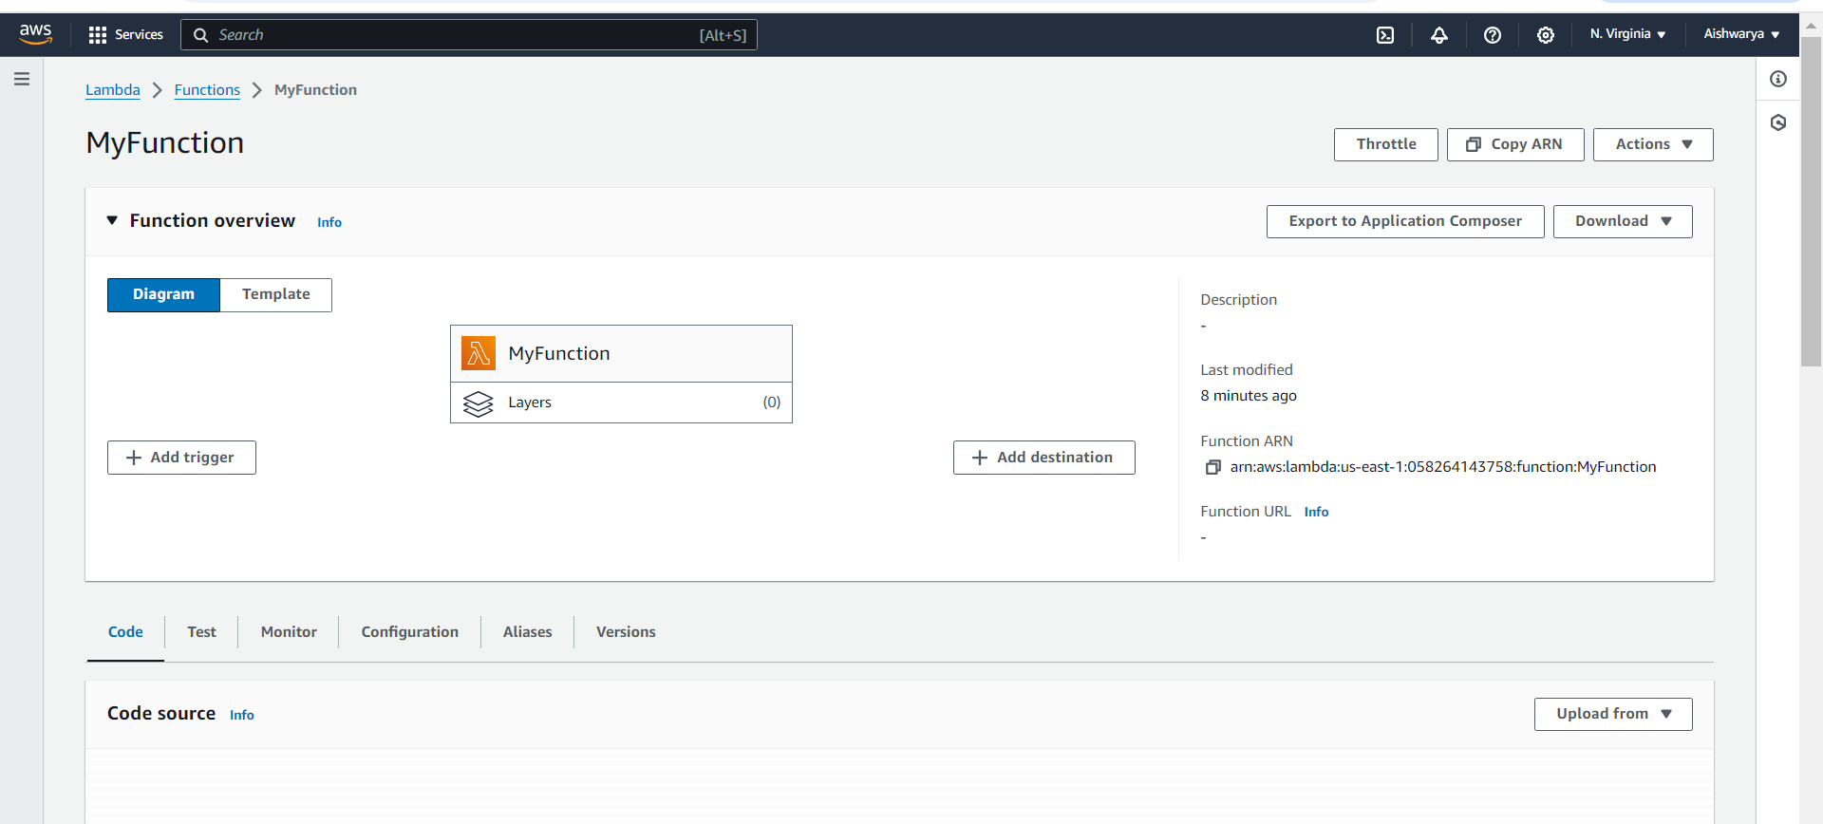

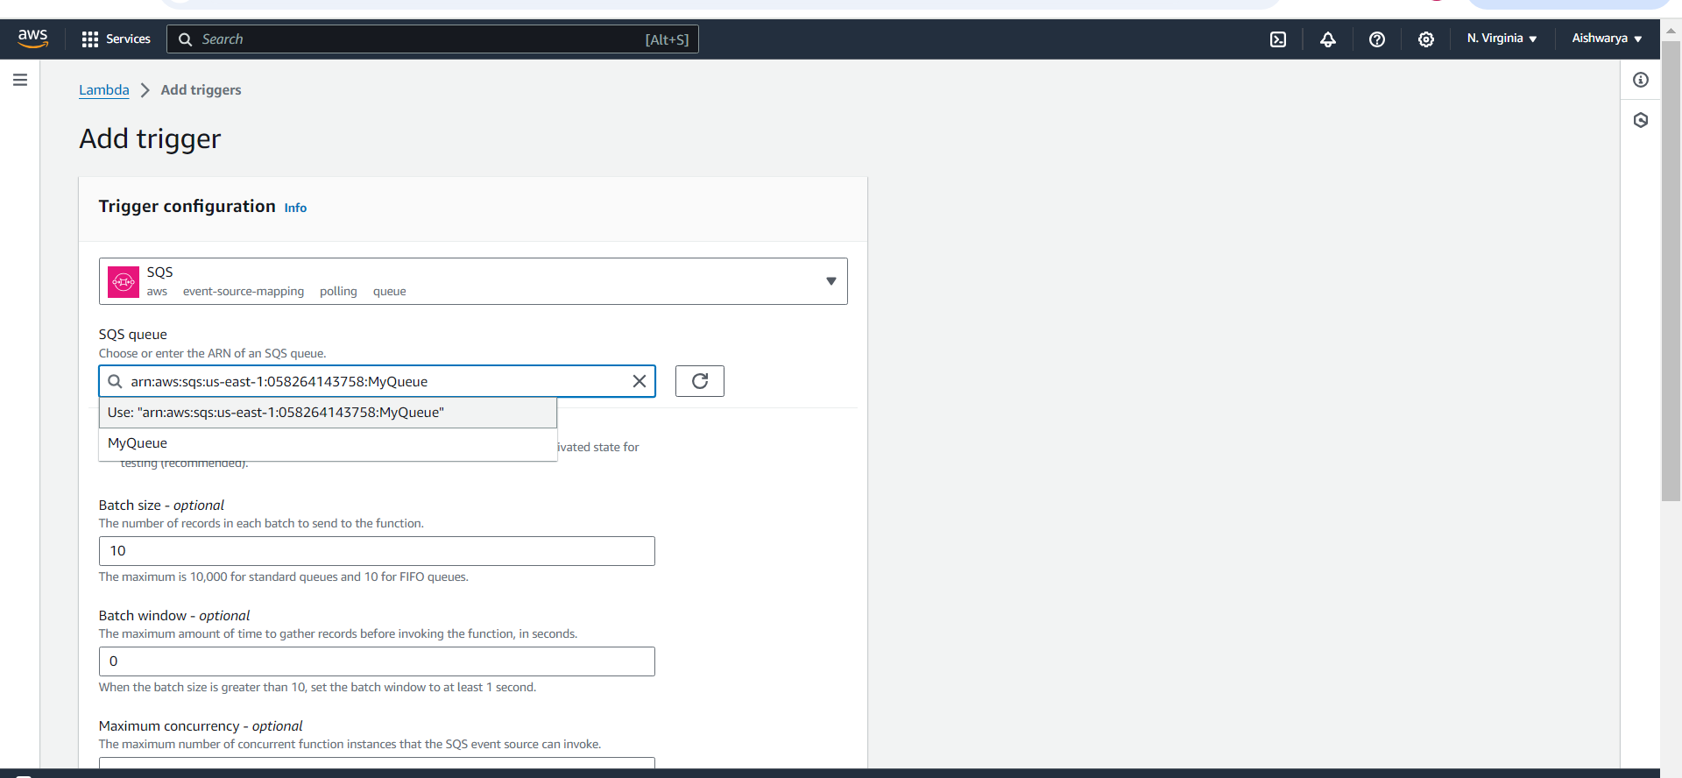

Error occurred while creating trigger so edit the role (by adding new inline policy)

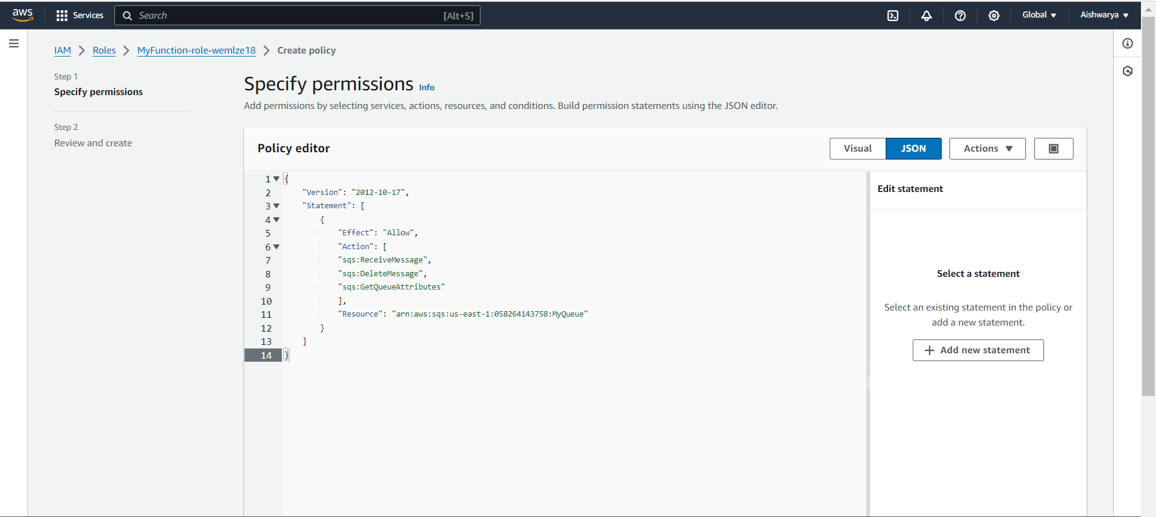

Now able to add trigger

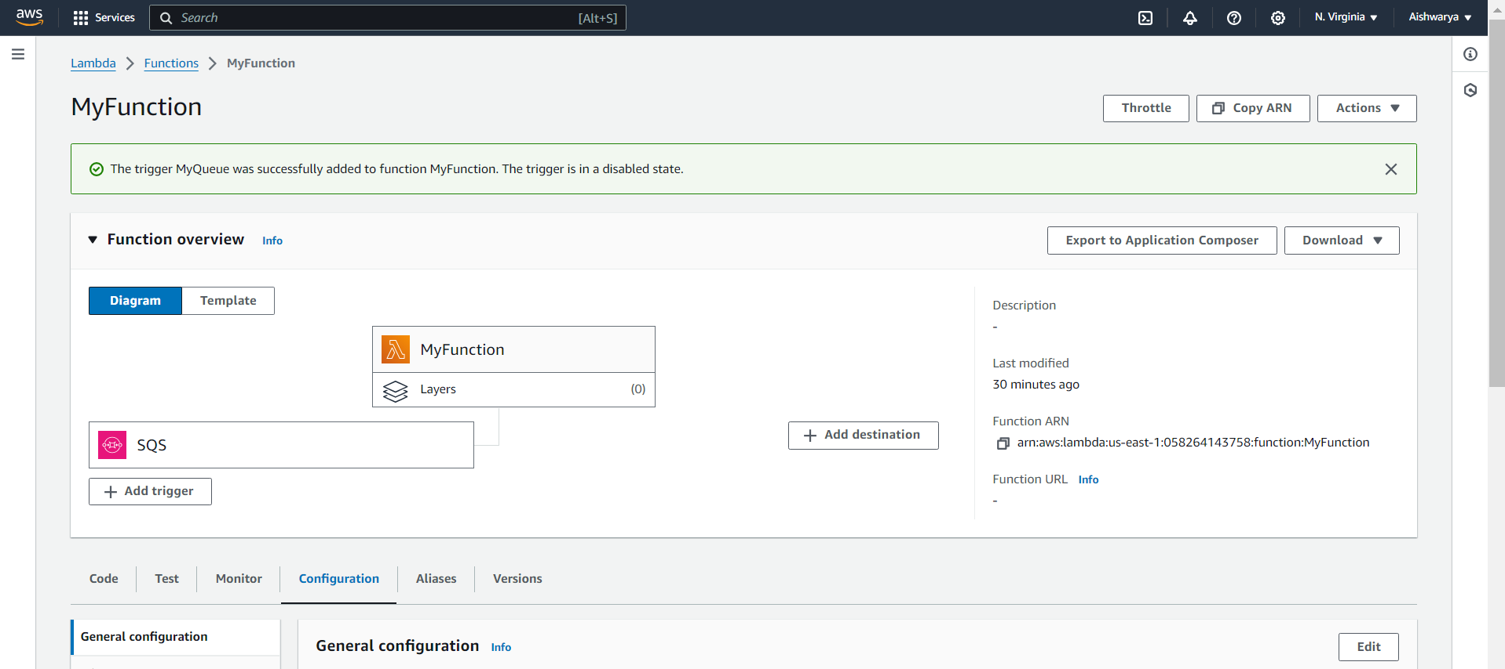

now we will send the message to sqs queue for testing :

Go to sqs queue and click on send and receive message:

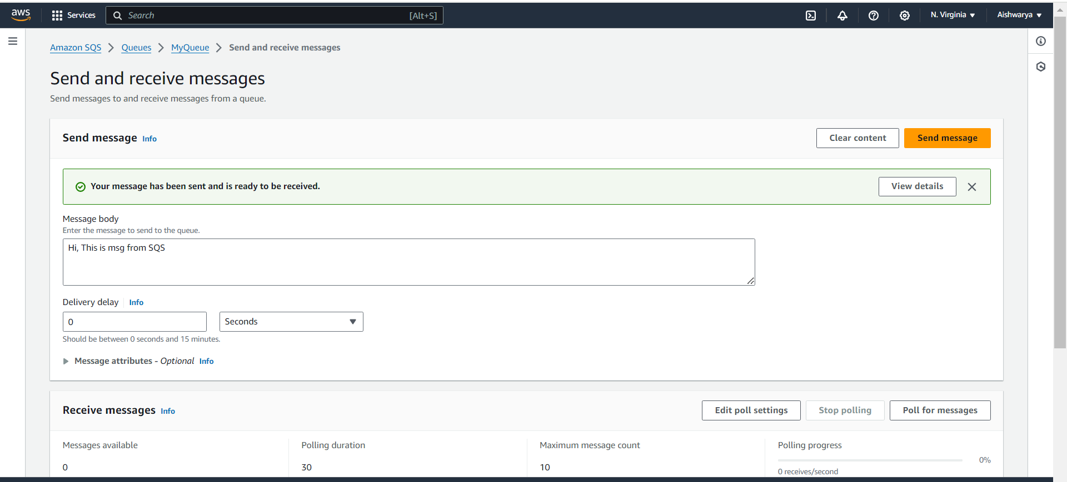

Now go to :

Cloudwatch——-> log groups——->/aws/lambda/myfunction---> scroll and

Check your message:

